Renju lesson on June 14, 2001

Hello all! Welcome to Online Renju Class. The first 17 moves are familiar for you already. What 18th move did we study last time? Yes L9. We were convinced of black power there. People used L9 often because that was the only 18th move that gave white some chance in case black would fail the attack. Any other 18th move gives black good position even after failed black attack.
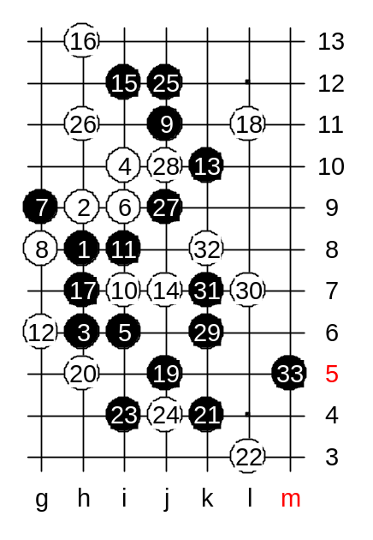
Today, let’s try 18-L11. Does black have VCT here? If no VCT then we need development, right? How to develop? And where? And what plan? In most cases, black will take f7 point sooner or letter. But be careful, timing is important. If you play f7 without having VCT threat, you know what will happen then? In this variant of 18_L11, the black key points are j5 and h11. There is some difference in development ideas, depending which move we use first. I personally prefer j5 for many reasons. The first is safety reason. By playing to j5 black neutralizes white’s right side potential, and that will let black continue further developments without worry. The second reason is – white will not have any chance to create any active material. For example, by playing h11 first, white may try some active block, and give black headache, how to reach to j5 later.
OK, we played j5 first. How should white block after j5? Lets try h5 block first, then try other moves. Black is very strong here. But, be careful. If you get too excited about your advantage, and rush to VCT, then you may have problems.
Does white have VCT threat? No. Then, we don’t need rush to have black VCT. We have enough time and freedom to develop more. We can ask “help” from upper side. Look at the black attack idea: k6, k7 (then white k8 – three). If white didn’t have that three, then black would easily win at m5. So, what if before attacking, we take care of that white future three?! We need a j9 stone. Surely we don’t play j9 now because it is too passive. So we play active j12, and prepare to control the j9 point. As you see, as soon as white got j9 point, the plan worked fine.

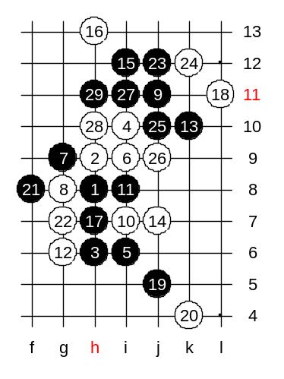
Lets try another 20th move. What do you suggest? It seems k4 is the best. Shall we try it? One thing is sure – black should not attack on the right side yet. It is too early and black force is not ready yet. It is hard to tell any favourite move here – I think black has many ways to attack. Russians used to play f8 here. It connects lower side, and prepares the power of j12 point.

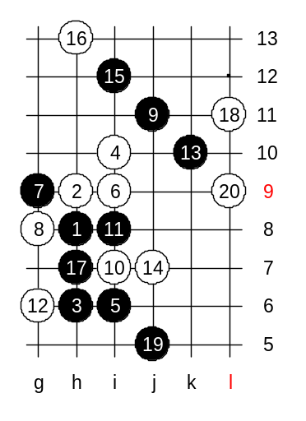

This is the medium level homework. Please find the black win.

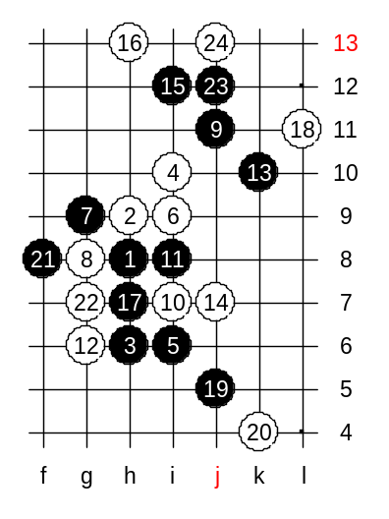

This is the advanced level homework. Please find the black win.

